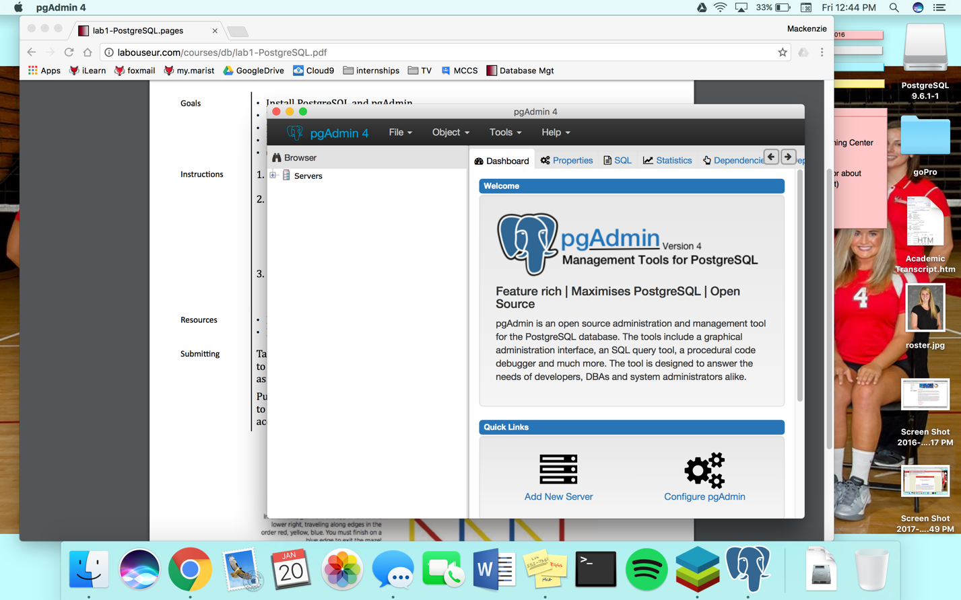

Mackenzie O’Brien

1/20/17

Lab 1

Essay 1: Data vs. Information

Netflix stores all of its movies and TV shows in a database. The elements of data include the show name, seasons numbers of the shows, and individual episode numbers, as well as the length of the film or episode. The data includes both numbers and strings which can be organized into data if given labels. An example of data vs information could be the number 120; the number could mean anything without context, but when given the label minutes or episode number, the data becomes information. Information becomes more valuable when given context because analysis can then be taken from it and hypothesis tested upon it. Without context, data is meaningless.

Essay 2: Data Models

The hierarchical model was created by IBM and branches down from bigger concepts to smaller ones. For example, a game may have player branches which may have branches containing items. The flaw of this is the odd branch from the game in which unused items stored, from the example is class, and the law of least astonishment which says that it doesn’t make sense for two players to have the same item, but not point to the same item. By pointing to the same item, the model is no longer hierarchical and becomes a network model. The network model is very similar to the hierarchical model, except that two nodes may point to the same branch in a circuit. The fault that still exists is that unused items are oddly placed and don’t make sense compared to the placement of the rest of the model. The XML model was designed to carry data with a focus on what the data is. XML is a software- and hardware-independent tool for storing and transporting data.